Name:

Class:

**Seafloor Spreading- A mechanism for plate tectonics**

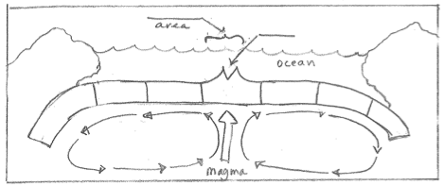

1. Label the Continental crust and color it green. Label the Oceanic crust and color the ocean ABOVE it blue. Which is thick/thin? Which is more dense/less dense? (Like angel food cake & a brownie).
2. Label the convection currents. Label the Mantle. What will happen to each of the oceanic crust plates because of the direction of these currents?
3. Label the rift valley. This is the center of the Mid Ocean Ridge; label it too. What comes out of the rift valley? When this hardens it crystallizes recording the direction of the magnetic field.
4. Label the young, middle and old rock on the oceanic crust. Color the youngest red, middle orange and old yellow. Why isn’t the rock all the same age? Why is the old rock split in half on opposite sides of the rift valley?
5. As the oceanic crust continues to push apart it eventually collides with the continental crust. Which crust piece goes under the other? How does density cause this? Label this area the subduction zone.
6. Label the deep ocean valley that is created, a Deep-sea Trench. What happens to the crust that goes back into the mantle? How should the age of the ocean rocks compare to the age of the continental rocks?

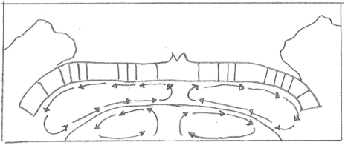

1. Label the convection in the mantle layer and in the outer core layer. Why can both of these layers move and the other layers don’t? Label the area of the outer core that is less dense and hotter. What are the sources of this heat?
2. As new ocean crust pours out and hardens, crystals called magnetite cool and harden aligned with the Earth’s magnetic field. The Earth’s current magnetic field is north facing. Label the newest magnetite rocks N for north.
3. From time to time the Earth’s magnetic field has reversed. Label the rock just past the newest rock with S for south facing magnetic field and then create the N, S, N, S pattern that is found on the ocean floor. What causes the earth to have a magnetic field? How could changes in this layer cause the changes in the magnetic field?
4. The N/S pattern in the ocean floor is a record of the ancient magnetic field. Color all the North N’s blue. What is this N/S magnetite pattern called? It is evidence for what process on the seafloor? What is the name of the theory that this process would cause?
5. What is some evidence for this theory from the continental crust?