Natural Selection – Major Concepts and Learning Activities
These Teacher Notes provide a review of major concepts and common misconceptions and a recommended sequence of learning activities to ensure that students develop a clear and thorough understanding of the process of natural selection. The recommended approach to learning about natural selection is aligned with the Next Generation Science Standards.

Major Concepts and Common Misconceptions
Major Concepts
- A typical population of biological organisms produces more offspring than can survive to reproduce.
- Different individuals in a population have different characteristics; this is variation.
- An adaptation is any characteristic or trait that increases fitness; fitness is the ability to survive and reproduce. (Notice that biologists use the terms adaptation and fitness to have different meanings than the common meanings of these words in everyday language.)
- A characteristic which is influenced by genes and can be inherited by a parent’s offspring is called a heritable trait.
- An adaptive heritable trait tends to become more common in a population. Because the trait is adaptive, individuals with this trait generally produce more offspring. Because the trait is heritable, offspring generally have the same trait as their parents. Therefore, the adaptive heritable trait tends to become more common in the population. This process is called natural selection.
- Natural selection results in changes in the frequency of heritable traits in a population. Natural selection does not cause changes in an individual.
- Evolution by natural selection occurs if and only if there is variation in a heritable trait which contributes to differences in fitness.
- Which characteristics are adaptive and how a population evolves depends on which type of environment the population is in. The same population will evolve differently in different environments. Natural selection is easiest to observe when the environment has changed so different characteristics are adaptive.
- In biological populations, evolution by natural selection usually occurs slowly over many generations.

Several Common Misconceptions
- Individual organisms can evolve during a single lifespan.
- Natural selection involves organisms trying to adapt.
- The "needs" of organisms account for the changes in populations over time (goal-directed or teleological interpretation).
- The fittest organisms in a population are those that are strongest, fastest, and/or largest.
Suggested Learning Activities
I recommend the following three-activity sequence. These activities build on each other to guide students in developing a solid understanding of the basic principles of natural selection.

1. To introduce the major concepts and counteract common misconceptions, I recommend "Evolution by Natural Selection" (http://serendip.brynmawr.edu/sci_edu/waldron/#evolution). In this minds-on, hands-on activity, students develop their understanding of natural selection by analyzing specific examples and carrying out a simulation. The questions in the introductory section introduce students to the basic process of natural selection, including key concepts and vocabulary. The second section includes a simulation activity, data analysis, and interpretation questions to deepen students' understanding of natural selection. In the third section, students interpret evidence concerning natural selection in the peppered moth and answer questions designed to consolidate a scientifically accurate understanding of how the process of natural selection can result in evolutionary change. (NGSS)

2. To further develop student understanding of natural selection, I recommend that the introductory activity be followed by "Selection and the Blond Beach Mouse" (http://sciencecases.lib.buffalo.edu/cs/collection/detail.asp?case_id=791&id=791). This case study engages students in understanding the adaptive value of blond fur for deer mice that live in sandy beach areas, as well as the molecular genetic mechanisms that result in blond fur. This PowerPoint presentation incorporates multiple questions for students, including questions related to the distinction between proximate and ultimate causes, a challenge to plan an experiment, and questions to analyze the results of a related published experiment. For a typical high school class, I recommend using Part I and the simplified version of Part II, and omitting Part III.

To help students understand the big picture and consolidate their understanding of natural selection, I recommend that you use a modified version of storyboarding with this case study. In this approach to storyboarding, students use the Natural Selection Storyboard (on page 5) (NGSS) as follows:
- Before students begin the Blond Beach Mouse activity, ask them to complete the Natural Selection Storyboard on page 5.
- As students progress through the Blond Beach Mouse activity, they can modify their storyboards.
- After completing the Blond Beach Mouse activity, students are given a new copy of the storyboard to complete (without looking at their earlier storyboard or the activity).
- After this, students should have prompt feedback so they can improve the accuracy and completeness of their storyboard; you can accomplish this in a class discussion where students compare their answers. This type of active recall with feedback helps to consolidate student understanding and retention of the concepts and vocabulary learned during the activity.
You may also want to have your students complete Oldfield Deer Mice and Blond Beach Mice: The Many Levels of Adaptation (on page 6) (NGSS) to clarify student understanding of how the same phenomena are observed at different organizational levels (molecular, organism, population, and ecosystem).

3. To begin the third recommended activity in this sequence, have students view Pocket Mouse Film with Quiz (available at http://www.hhmi.org/biointeractive/pocket-mouse-film-quiz). If you show this video in class, I recommend that you have your students vote on each question at the appropriate place in the video. If many students give incorrect answers to a particular question, have students discuss in small groups and try to figure out the right answer together, and then re-vote. After the film, ask students to complete the Rock Pocket Mice Analysis (shown on pages 7-8) (NGSS) and then discuss. This activity will help to reinforce student understanding of natural selection, including the contributions of mutations and migration to the heritable variation that is needed for natural selection to occur.

Additional Recommended Activities
A more extensive sequence of activities for teaching students about natural selection is proposed in "Making Sense of Natural Selection" (The Science Teacher 80 (6): 43-49, 2013) (NGSS). For example, to familiarize students with variation in natural populations, you can use "Natural Selection and Variation in Birds" (http://csip.cornell.edu/Curriculum_Resources/CSIP/Ardia/default.html).

Student understanding of natural selection can be enhanced by having them apply their understanding to analysis of the variety of phenomena, as presented in the following activities:
- "Using Molecular and Evolutionary Biology to Understand HIV/AIDS and Treatment" (http://serendip.brynmawr.edu/exchange/bioactivities/HIV ) (NGSS)
- "Monarch/Viceroy case" (http://ncisla.wceruw.org/muse/naturalselection/materials/section4/lesson4A/index.html)
- "The Origin of Species: The Beak of the Finch" a 16-minute video (http://www.hhmi.org/biointeractive/origin-species-beak-finch) together with the classroom activity, "Evolution in Action: Graphing and Statistics" (http://www.hhmi.org/biointeractive/evolution-action-data-analysis) (The video can also serve as an introduction to discussion of speciation.)
You may also want to show the video, “Malaria and Sickle Cell Anemia” (https://www.youtube.com/watch?v=Zsbhvl2nVNE). This video describes the research that led to our understanding of how natural selection resulted in relatively high frequencies of the sickle cell allele in some populations exposed to malaria.

“Evolution and Adaptations” (http://serendip.brynmawr.edu/exchange/bioactivities/evoadapt) is an analysis and discussion activity for students who have a basic understanding of natural selection. In common experience, the term "adapting" usually refers to changes during an organism's lifetime. In contrast, evolutionary biologists use the term "adaptation" to refer to a heritable trait that increases fitness. To help students reconcile these different concepts, this activity introduces the concept of phenotypic plasticity (the ability of an organism to adapt to different environments within its lifetime). Questions guide students in analyzing how the balance between the advantages and disadvantages of a characteristic (e.g. an animal’s color) can vary in different circumstances, how phenotypic plasticity can be a heritable trait that can optimize fitness in a variable environment, and how natural selection can influence the amount of phenotypic plasticity in a population. (NGSS)

Alignment with National Standards
The recommended sequence of three learning activities is aligned with the Next Generation Science Standards. Specifically:
      - Students will gain understanding of two Disciplinary Core Ideas:
      - LS4.B Natural Selection. "Natural selection occurs only if there is both (1) variation in the genetic information between organisms in the population and (2) variation in the expression of that genetic information – that is, trait variation – that leads to differences in performance among individuals. The traits that positively affect survival are more likely to be reproduced, and thus are more common in the population."
      - LS4.C Adaptation. "Natural selection leads to adaptation, that is, to a population dominated by organisms that are anatomically, behaviorally, and physiologically well suited to survive and reproduce in a specific environment. That is, the differential survival and reproduction of organisms in a population that have an advantageous heritable trait leads to an increase in the proportion of individuals in future generations that have the trait and to a decrease in the proportion of individuals that do not. Adaptation also means that the distribution of traits in a population can change when conditions change."
- Students will engage in several Scientific Practices:
- developing and using models
- using mathematics
- analyzing and interpreting data
- constructing explanations
- arguing from evidence.
- These activities provide the opportunity to discuss the Crosscutting Concepts, "cause and effect: mechanism and explanation", "systems and system models", and "stability and change".
- These activities help to prepare students for the Performance Expectations:
- MS-LS4-4, "Construct an explanation based on evidence that describes how genetic variations of traits in a population increase some individuals' probability of surviving and reproducing in a specific environment."
- MS-LS4-6, "Use mathematical representations to support explanations of how natural selection may lead to increases and decreases of specific traits in populations over time."
- HS-LS4-2, "Construct an explanation based on evidence that the process of evolution primarily results from four factors: (1) the potential for a species to increase in number, (2) the heritable genetic variation of individuals in a species due to mutation and sexual reproduction, (3) competition for limited resources, and (4) the proliferation of those organisms that are better able to survive and reproduce in the environment."
- HS-LS4-3, "Apply concepts of statistics and probability to support explanations that organisms with an advantageous heritable trait tend to increase in proportion to organisms lacking this trait."
- HS-LS4-4, "Construct an explanation based on evidence for how natural selection leads to adaptation of populations."

Natural Selection Storyboard

This figure shows a mainland deer mouse (in the bottom right corner of the figure) and eight subspecies of beach mice. The beach mice evolved from mainland mice that migrated to sandy beaches ~3000 years ago.

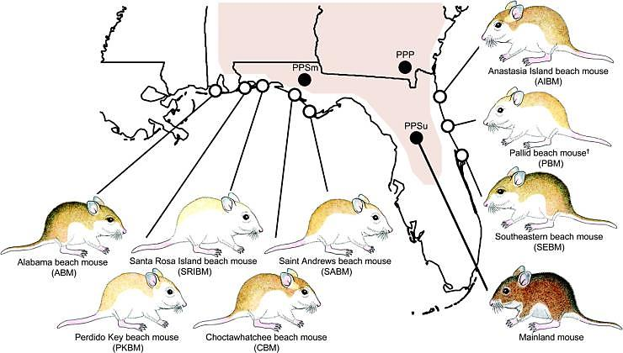

1. Explain the processes that resulted in the different fur color of beach mice compared to mainland mice. Summarize key evidence that supports your explanation. Include answers to these questions in your explanation:
- What random process was necessary for beach mice to evolve from dark mainland mice?
- What non-random process was necessary for beach mice to evolve from dark mainland mice?

Oldfield Deer Mice and Blond Beach Mice: The Many Levels of Adaptation

1. Describe the differences for these two populations of mice for each of the levels listed.

Organizational Level | Mainland Fields | Gulf Coast Beach
Ecosystem

Population

Organism

Molecular

2. What are mutations? How do they occur? (Your answers should be at a molecular level.)

3. Give a brief explanation of natural selection that includes:
- how natural selection is related to the environment (ecosystem level)
- how natural selection can produce changes in a population
- how natural selection acts on individual organisms
- the role of mutations and different alleles of a gene (molecular level).

Rock Pocket Mice Analysis

This diagram represents a population of sandy colored rock pocket mice that live on sandy colored rock next to dark volcanic rock that is cooling after a recent volcanic eruption.

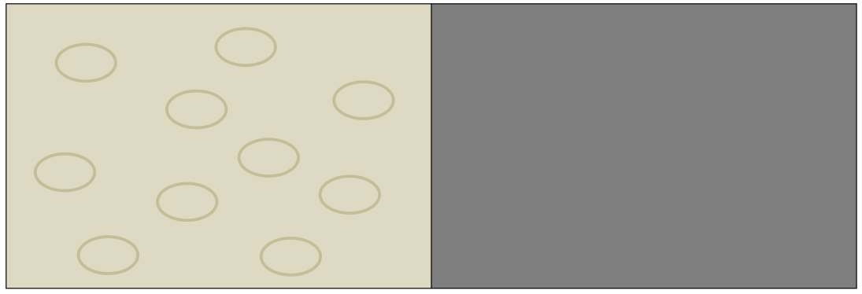

The diagram below shows the population of mice a few years after the dark volcanic rock had cooled enough for mice to live there.
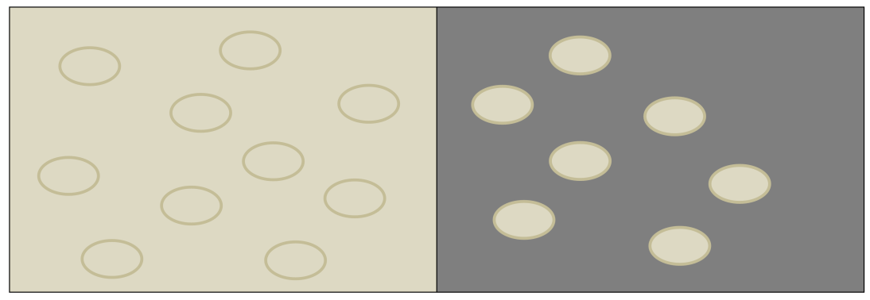

1. How did the population of mice change between the first diagram and the second diagram? What processes contributed to this change? (Include the words births, deaths and migration in your explanation.)

2. Suppose that thousands of years later a new type of mouse with dark fur appeared in the population of mice on the volcanic rock. What process or processes could have resulted in this new type of mouse?
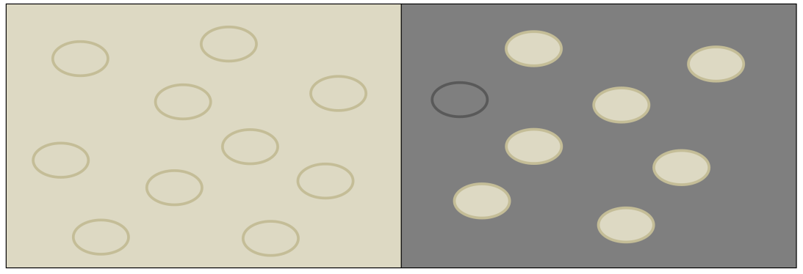

3a. What changes do you think would occur in the mouse population on the dark volcanic rock during the years after this new type of mouse with dark fur appeared?

3b. What processes would cause the predicted changes in the population to occur? (Include the terms adaptation, fitness, natural selection, reproduce and survive in your answer.)

4. Imagine a different scenario in which an albino mouse was born into the population of sandy-colored mice on the dark volcanic rock. What change do you think would occur in the mouse population on the dark volcanic rock during the years after the albino mouse appeared? Explain why this change would occur.
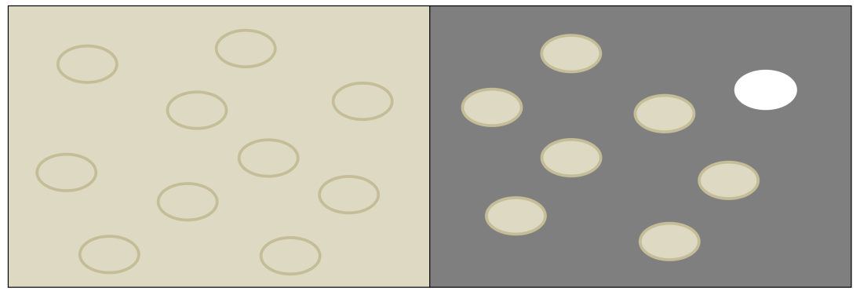

5. Researchers have found that, for one population of rock pocket mice that live on dark volcanic rock, all the mice have sandy colored fur. This population of rock pocket mice lives on relatively young volcanic rock (<800 years old) far from any population of dark rock pocket mice. How can you explain why the mice in this population have not evolved dark fur even though they live on dark volcanic rock?

By Ingrid Waldron, Department of Biology, University of Pennsylvania, 2016 with helpful input from Ray Howanski, Ridley School District. These Teacher Notes are available at http://serendip.brynmawr.edu/exchange/bioactivities/NaturalSelectionOverview .
Additional resources for teaching about other aspects of evolution are provided in Resources for Teaching and Learning about Evolution (http://serendip.brynmawr.edu/exchange/bioactivities/evolrec).
See page 4 for a description of how the proposed sequence of activities is aligned with the Next Generation Science Standards (http://www.nextgenscience.org/next-generation-science-standards). Individual activities that are explicitly aligned with the Next Generation Science Standards are designated by NGSS.
Most of these misconceptions are excerpted from Misconceptions about evolution, available at http://evolution.berkeley.edu/evolibrary/misconceptions_teacherfaq.php
This general approach is described in "Using Storyboarding to Model Gene Expression", American Biology Teacher 77:452-457, 2015.
Both the case study and the storyboard refer to mutation as a random process and natural selection as a non-random process. Mutation is a random process in the sense that, as far as scientists have been able to determine, there is no tendency for genes to mutate to a useful allele in a particular environment. Useful mutations are often present in a large population before the population is exposed to the environment where the mutations will be useful. This is probably all that your students need to know, but you may want to know that mutations are not entirely random; for example, rates of mutation differ in different parts of the genome in ways that appear to be adaptive.
Note that rock pocket mice (Chaetopidus intermedius) are a different type of mice than oldfield and beach mice (Peromyscus polionotus).
Next Generation Science Standards (http://www.nextgenscience.org/next-generation-science-standards)

