Understanding The Solar System:
Accretion Theory

Step #1: What do you see in the 3 pictures? What is happening? How is this happening?

5-6 Billion years ago
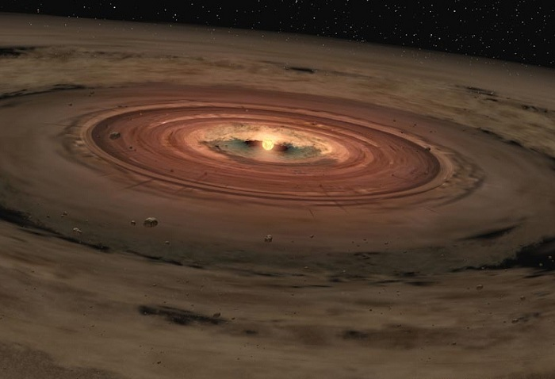

4.5-5 Billion years ago
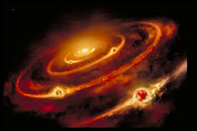

Today
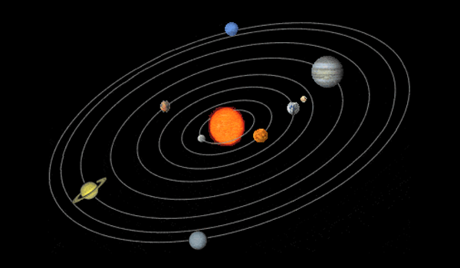

Write down your thinking –

2. Talking Sticks Protocol:
Each person places his or her pencil/pen in the center of the group.
- Take turns making a comment about the picture progression by picking up your “talking stick” and making your comment while you hold it.
- Once you are finished with your comment, set your “talking stick” in front of you and you’re are not allowed to comment again until all the other group members have had a turn (no member is allowed to pass!).
- After everyone in the group has had a chance to comment, repeat the process.

3. Summary:
- Read one paragraph silently. Each person reads silently to themselves and only when all in the group are finished with the paragraph does the group progress to the next step.
- Group discusses the content of the paragraph. All group members should contribute.
- Group comes to consensus about main ideas.
- Talk about how to write the main idea(s).
- Each group member writes down the main idea(s).
- Repeat steps 2-5 for each paragraph of the reading.

Paragraph 1:

Paragraph 2:

Paragraph 3:

Paragraph 4:

Paragraph 5:

Paragraph 1:
The Solar System started as a cloud of gas and dust that slowly collapsed into a flattening disk. Initially, dust grains grew into larger and larger clumps through simple collisions, but over time objects grew large enough that they also began to grow by gravitationally attracting nearby material. This type of an accretion process tended to form bodies rotating in the same direction that the disk rotates.

Paragraph 2:
This model also explains the spacing of the planets. Studies suggest that if two large bodies started growing in orbits that were too close together, they would eventually grow large enough, as they gravitationally cleared out their orbit, to attract each other gravitationally, collide, and merge. In this way, the solar nebula divided into donut-shaped zones around the Sun, each about 1.5 to 2 times as wide as the one next closer to the Sun. The result is just one planet dominating each zone. (This is actually part of the definition of a planet, and is part of why Pluto in its shared orbit isn't a planet.)

Paragraph 3:
Terrestrial Planets. In the inner part of the Solar System, the process of accretion continued until Mercury-sized to Earth-sized planets had formed. Most of the planetesimals in this region were made of silicate (rocky) material — this close to the Sun, it was too warm for ices to remain solid. The terrestrial planets grew in this ice-less environment until most of the silicate material in the area was swept up. An out-rushing of gas and radiation from the young Sun blew away the remaining gas and dust left behind.

Paragraph 4:
Giant Planets. The giant planets formed in the same way as the terrestrial planets, from accreting planetesimals. Farther from the Sun, the giant planet zone contained icy as well as rocky material, which augmented local planetesimal masses. Thus the embryo planets — called proto-planets — that would become Jupiter, Saturn, Uranus, and Neptune grew larger than Earth and the other terrestrial planets. When they reached about 10 to 15 times the mass of present-day Earth, their gravity was strong enough to pull in gas from the surrounding solar nebula. This is why they accreted not only solid planetesimals, but also massive atmospheres of gas with a composition approximately that of the nebular gas.

Paragraph 5:
Asteroid belt. Asteroids are planetesimals that never made it all the way to "planethood." Why were most asteroids stranded in the zone between Mars and Jupiter? Probably because it was the planet-forming zone closest to the largest planet in the Solar System. This caused them to smash into innumerable fragments when they collided, instead of coalescing into an even-larger body.

